Unexpected error causes inconsistency of data.

1.1 Design Problem
Current design doesn’t have proper rollback mechanism of data. if any unexpected error happens after updating store item information, then store data will be inconsistent state. We might want to revert the changes if any unexpected exception. Example in case of Give change scenario, if any exception occur need to restore the cash store to it previous state.

1.2 Pattern Selection

1.2.1 Candidate Design Patterns
- State
  - Allow object to alternate its internal behavior when it’s internal state changes.
- Memento
  - Allow object to record an object internal state without violating encapsulation and reclaim it later.

1.2.2 Motivations to Choose
Memento pattern is selected to solve this problem.
Reasons for choosing:
- Give change stores coin store information in memento. In case of VMCS Exception it will restore cash store from memento.
- Store Item is light weight objects. So creating copy of cash store item will not impact system performance.

1.3 Design Changes

1.3.1 Initial Design
Give Change Class Diagram
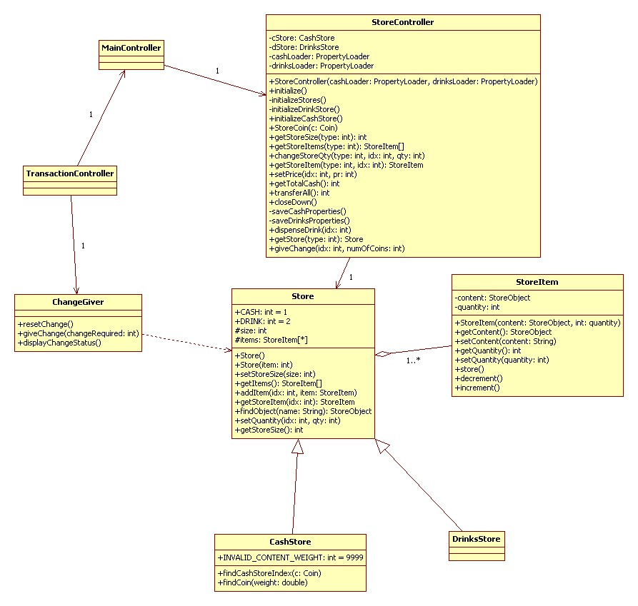
Give Change sequence Diagram
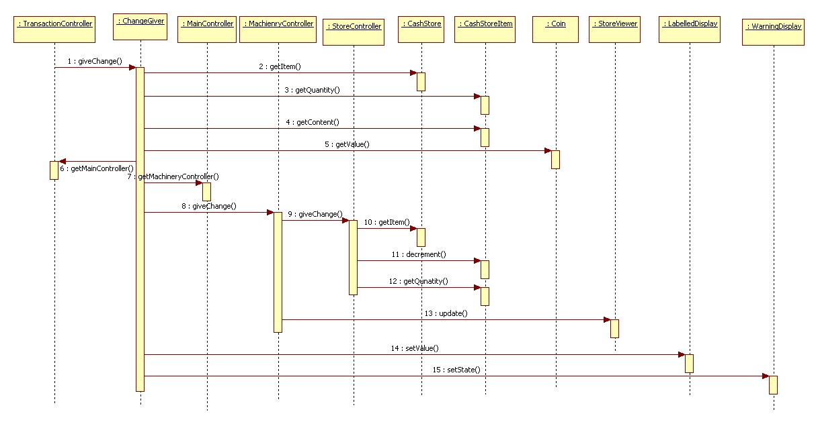

1.3.2 Modified Design
Give Change Class Diagram
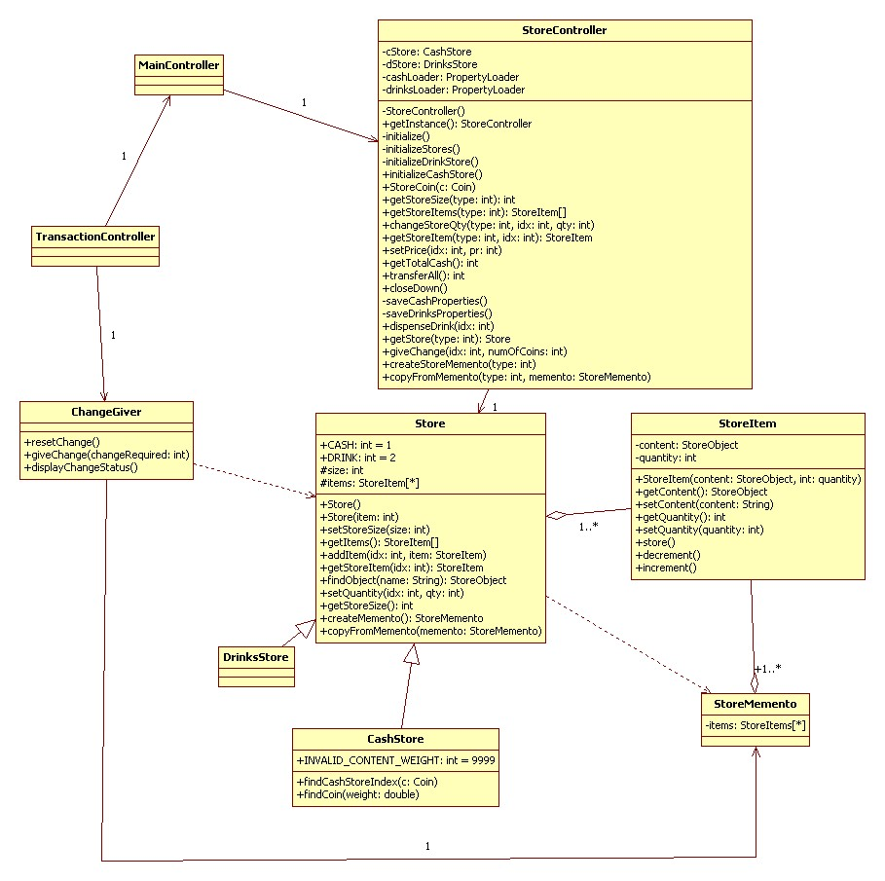
Give Change sequence Diagram
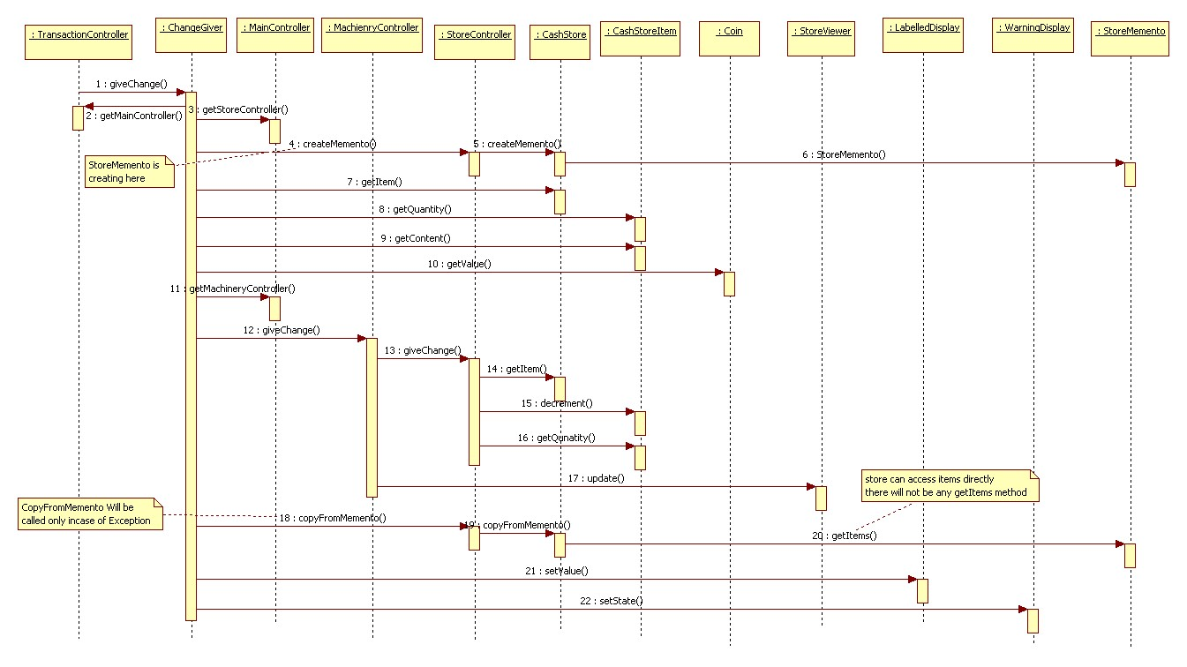

1.4 Implementation
- Language support
  - Using java inner class to support the narrow interface. Memento internal state can only be accessible from Store.
  - Cash store having few store items. Creating full copy of cash store object every time.

